**Implementing an artificial neuron from scratch**

*Transforming input to output, using neural function*

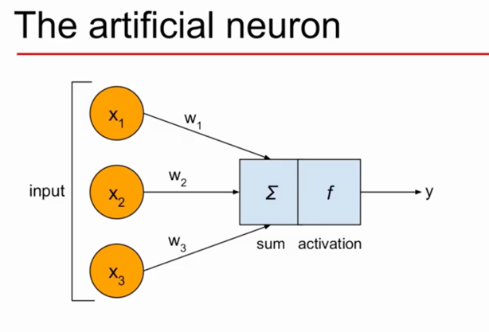

Step 1: x -> input;

w -> weight of input

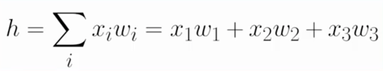

Step 2: Substitute h in any *activation function, f()* as f(h)



ANNs:

1. Single neuron is suitable for linear problems
2. Real world problems are complex
3. ANNs can reproduce highly complex nonlinear functions

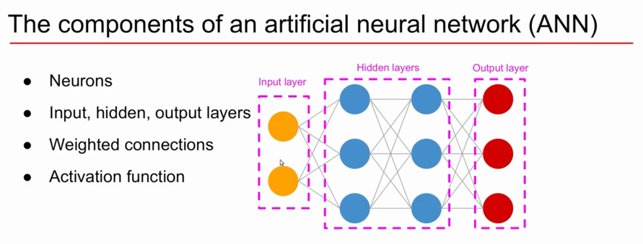

**Multilayer Perceptron (MLP)**

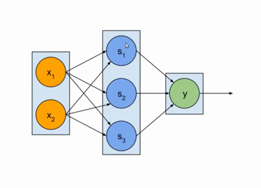

1. Net Inputs

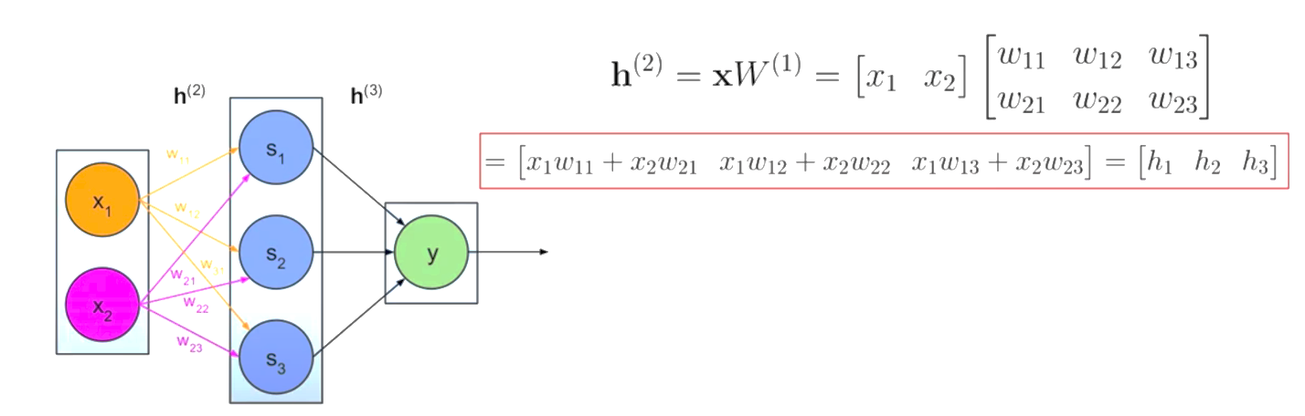



1. Activations

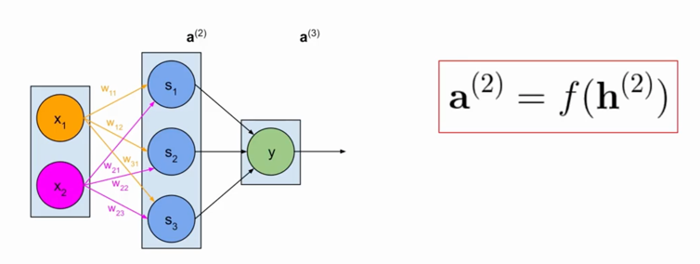



1. Output layer

